CPSC 4317: Computer Networks
Assignment 3
Due 10:00am Oct. 4, 2024 (Friday)

Name: ___Andrew Kalathra___

LUID: ______L20498001______

Date: ______10/4/2024_______

1. Please write down the pseudo-code for CSMA/CD algorithm (15 points)

1. Method (as per Ch 14.6, slide 27):
2. Wait for a packet to be ready;
3. Wait for the medium to be idle (carrier sense);
4. Delay for the interpacket gap;
5. Set variable x to the standard backoff range, d;
6. Attempt to transmit the packet (collision detection);
7. While( a collision occurred during previous transmission) {
8. Choose q to be a random delay between 0 and x;
9. Delay for q microseconds;
10. Double x in case needed for the next round;
11. Attempt to retransmit the packet (collision detection);
12. }

2. Why does CSMA/CD use a random delay? (10 points)

- As we can see by the above pseudocode, a delay is set on lines 8 and 9.
- This delay is randomly generated between the range of 0 – x, where x double each time the while loop iterates.
- When generating the random time delay, it becomes less likely each time for a collision to occur as a random number chosen by two people is less likely to be the same from a range of 0-20 than in the range 0-10.
- In this way, we are almost always sure that there will not be a collision eventually, allowing the packets to be transmitted successfully.

3. What is the hidden terminal problem? What is the exposed terminal problem? (15 points)

- When in a local area network (LAN), there is low visibility of other devices over long ranges.
- As such, when nodes want to communicate with each other, they cannot detect collisions at a certain node if another node is sending frames to that node.
- An example is as such:
  - We have 3 nodes: A, B, and C
  - B is in the range of both A and C
  - A only lies in the range of B, so C is invisible to A
  - C only lies in the range of B, so A is invisible to C
  - 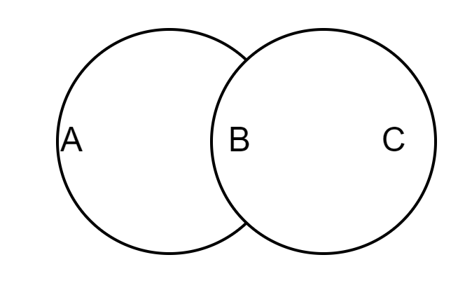
  - If C wants to send a packet to B, and at the same time, A wants to send a packet to B, they will not detect any collisions.

4. Please write down the pseudo-code for CSMA/CA algorithm (15 points)

1 Method:
2 Wait for a packet to be ready;
3 Send RTS to destination node;
4 While(RTS collision){
5 Choose q out of range from 0 to x;
6 Delay for q microseconds:
7 Resend RTS;
8 }
9 Wait for CTS from destination node;
10 Attempt to transmit packet;

5. Why do we need byte stuffing? (10 points)

- Byte stuffing is a term related to clarifying confusion given by ASCII conversions for SOH and EOT
- Byte stuffing provides alternative codes for these to make sure that payload information is not mixed up with the SOH and EOT.
- An example of this can be found when converting:
  - SOH → ESC A
  - EOT → ESC B
  - ESC → ESC C

6. (35 points) Modify the client.c and server.c program from Assignment 1 to add the following function: when the client connects to the server, the client provides the name of a directory D to be retrieved in the server;

When the server receives the request, the server reads the name of the directory D, retrieves the contents from the directory D, and sends the contents back to the client.

The client, after receiving the contents from the server, prints out the content.

Hint: 1. Use opendir() to open a directory; use “man opendir” to check more details;
2. Use readdir() to read contents under a directory: use “man 3 readdir’ to check more details
3. Use closedir() to close a directory

How to Turn In:

Only softcopy is required.
- Please use the blackboard system to turn in the softcopy of all your solutions.

